New Balance began as a Boston-based arch support company in the early 1900's, developed into a specialized shoe manufacturer in the 1970's, and has grown to become a leading global athletic products company. Today New Balance is a family of brands including New Balance, Dunham, PF Flyers, Aravon, Warrior and Brine.

To ensure the best fitting, best performing shoes and apparel, we focus on improving our technology and production methods. We have maintained five manufacturing facilities in New England where we continue to rely on the skills and teamwork of our American workforce to produce a percentage of our athletic footwear. We have also remained strongly committed to a core set of company values that include integrity, teamwork and total customer satisfaction.

This design document will serve as the guide to content development for New Balance for shred retail operations. After this design document is reviewed and approved, all content will be gathered to support the specified learning objectives. The guidance in this document, once approved, is considered sufficient to move to the Development process step.

# Team Members

* Rick DiMichele – Manager, IT, LMS
* Spencer Poole – Learning Operations, IT
* Ashley Renzi – Director, Learning Program Manager
* Dean Biele, CTO

# Executive Summary

# Introduction

Design Document

New Balance

eLearning course



October 24, 2014

Dean Biele

CTO

508.624.9100

Inside This Document

1 Introduction

2 Business Drivers

2 Delivery Method

2 Deliverables

3 Technical Considerations

3 Assumptions

4 Objectives

4 Course Outline

5 Development Timeline

# Deliverables

* eLearning Storyboard
* eLearning module developed in Flash/HTML
* Assessment exercises for eLearning
* 6 courses

# Delivery Method

# Department Profile: Name of Department

The learning will consist of six eLearning module.

* eLearning – This method will be used primarily for training. Participants will spend time working on their own at a computer a taking self-paced course. This method may also be used to deliver specific scenario based learning event that will be included as a part of this course.
* Course Length: Approximately 120 Minutes Total.

**Required**!

This course will be required to take annually.

Overall **business goals** of this project:

▪ The primary goal is to rewrite and refresh the information/courses.

▪ Provide consistent training and information in a timely manner to employees.

▪ New Balance will be launching a new learning initiative. This courseware will provide fresh and exciting content, branding and interactivity to reflect New Balance‘s initiative.

o New Balance‘s marketing and branding initiative will be updated within the courseware providing a consistent message and experience reflecting corporate goals.

▪ The training and courses for RSAs affiliated with NB will create brand ambassadors at the retail level and control the brand message that will eventually be communicated to the end consumer.

# Business Drivers

**Target Audience**:

Front line and managers: Retail Sales Associates (RSA), New Balance associates.

General Managers and below will take this course.

# Technical Considerations

Certain technical considerations must be made in order for this program to be successful:

* Access to images and media to use within the course.
* Computers (thin clients) need to be available to the learners at the time of training.
* Learners will need to be set up in the LMS to take the eLearning modules and simulations.

# Assumptions

The following are assumptions about the current capabilities and dependencies that may impact development and implementation of the curriculum:

* It is the responsibility of New Balance Athletic Shoe, Inc. to provide subject matter expertise and timely review of materials, when required.
* New Balance Athletic Shoe, Inc. will make available staff (part- or full-time equivalent) resources to InVision as deemed necessary and mutually agreed by New Balance Athletic Shoe, Inc. and InVision. Staff may consist of SMEs, writers, IT staff, marketing, networking staff and stakeholders.
* New Balance Athletic Shoe, Inc. will provide the required resource support during the project to review deliverables at desired stages of the project. A quick turn-around time for review of materials is to be expected (one to two days, if not otherwise indicated in writing by the Project Manager and/or relevant InVision Learning staff).
* Updates, changes or fluctuations in New Balance Athletic Shoe, Inc. documentation thatwould be reflected in the WBT will result in additional costs.
* InVision Learning will meet virtually with New Balance Athletic Shoe, Inc. staff at the
* project‘s kick-off meeting, design and development, and delivery. Meeting methods such as WebEx, e-mail, phone, and on-line collaboration will be used as required.
* External compatibility testing can be included for an additional charge.

▪ Introduction

▪ Course Overview

▪ Lesson 1:

* Training Objectives
* New Balance History
* Numbering System
* Did you Know?
* Made in the USA

▪ Lesson Two:

* Training Objectives
* Widths
* Determining Width and Size
* Check Fit
* Marketing Support
* Multiple Platforms
* Lasts
* Lasting
* Arch Types
* Biomechanics of Running
* Pronation, Overpronation, Supination
* Motion Control

▪ Session 1: Activity

▪ Session 1: Test

# Course Outline.

And six (6) online courses:

* “Session 1: New Balance 101 and New Balance Fit”
* “Session 2: Outsole Technology”
* “Session 3: Midsole Technology”
* “Session 4: Upper Technology”
* “Session 5: Apparel Technology, Construction, and Socks”.

# Objectives

# Development Timeline

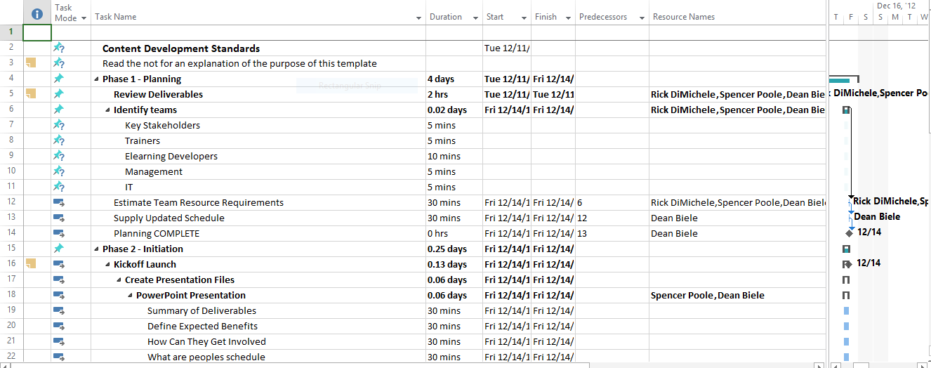

|  |  |  |  |  |  |  |
| --- | --- | --- | --- | --- | --- | --- |
| November 2015 | | | | | | |
| S | M | T | W | T | F | S |
|  |  |  |  | 1 | 2 | 3 |
| 4 | 5 | 6 | 7 | 8 | 9 | 10 |
| 11 | 12 | 13 | 14 | 15 | 16 | 17 |
| 18 | 19 | 20 | 21 | 22 | 23 | 24 |
| 25 | 26 | 27 | 28 | 29 | 30 |  |

|  |  |  |  |  |  |  |
| --- | --- | --- | --- | --- | --- | --- |
|  | | | | | | |
| December 2015 | | | | | | |
| S | M | T | W | T | F | S |
|  |  |  |  |  |  | 1 |
| 2 | 3 | 4 | 5 | 6 | 7 | 8 |
| 9 | 10 | 11 | 12 | 13 | 14 | 15 |
| 16 | 17 | 18 | 19 | 20 | 21 | 22 |
| 23 | 24 | 25 | 26 | 27 | 28 | 29 |
| 30 | 31 | 1 | 2 | 3 | 4 | 5 |

|  |  |  |  |  |  |  |
| --- | --- | --- | --- | --- | --- | --- |
| October 2015 | | | | | | |
| S | M | T | W | T | F | S |
|  | 1 | 2 | 3 | 4 | 5 | 6 |
| 7 | 8 | 9 | 10 | 11 | 12 | 13 |
| 14 | 15 | 16 | 17 | 18 | 19 | 20 |
| 21 | 22 | 23 | 24 | 25 | 26 | 27 |
| 28 | 29 | 30 | 31 |  |  |  |

# Sign Off

Please review this entire document for its content to ensure that the design has captured the business need and solutions accurately. Please approve this plan by sending an email to Lori Biele indicating your approval.

* Sign-off – Design is complete and accurate as is
* Changes noted – Design is fine with corrections marked

By electronically signing this document, we agree to all items outlined with regard to the plan, commitments on content provided

Please note that any change to the scope or design, delays in providing content by agreed upon deadlines, or delays in the review cycle may put the completion of the training for launch at risk.

Approver #1: Dean Biele

|  |  |  |
| --- | --- | --- |
| **Name** | **Sign-off (date)** | **Changes Noted (date)** |
| Dean Biele | 11/3/15 |  |
|  |  |  |

**Final Sign-off (if changes made above)**

|  |  |  |  |
| --- | --- | --- | --- |
| **Name** | **Date** | **Name** | **Date** |
|  |  |  |  |
|  |  |  |  |